**R.ABHINAV**

**CB.EN.U4CSE19453**

**Various tools for the Yahoo attack:**

**Malware:**

**Phishing:** The hack began with a spear-phishing email sent in early 2014 to a Yahoo company employee. It's unclear how many employees were targeted and how many emails were sent, but it only takes one person to click on a link, and it happened. Unimaginable that Yahoo did not sufficiently step employees through new-school [security awareness training](https://www.knowbe4.com/products/enterprise-security-awareness-training/) to prevent disasters like this.

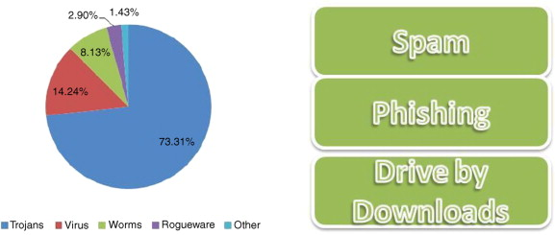

**Solution to Database & File Security problem:**

A complete solution to either the security or the privacy problem requires the following three steps:

1. **Policy:** The first step is to create a security or privacy policy. This policy accurately defines the requirements implemented inside the hardware and software of the computer system and outside the computer system. This includes physical, human and procedural control.
2. **Mechanism**: Security or privacy policies are embodied in the mechanisms required to implement the policy requirements. It is important that the mechanism performs the intended function.
3. **Assurance:** The final step deals with warranty issues. It contains guidelines to ensure that the mechanism meets policy requirements with a high level of security. Security is directly related to the work required to break the mechanism. The low warranty mechanism is easy to implement, but relatively easy to break. High-guaranteed mechanisms, on the other hand, are notorious for being difficult to implement.

The high-level objectives of security are well known:

1. **Secrecy** (or confidentiality), which is concerned with unauthorized disclosure of information.
2. **Integrity**, which is concerned with unauthorized modification of information or processes; and
3. **Availability**, which is concerned with improper denial of access to information.